Information

NAME

NAME OF SPOUSE (IF MARRIED)

STREET ADDRESS

CITY / STATE / ZIP CODE

HOME PHONE

MOBILE PHONE

EMAIL ADDRESS

EMAIL ADDRESS OF SPOUSE (IF MARRIED)

Dependent Children’s names and birthdates:

May we include your contact information
in the parish directory?

 yes  no If yes, please indicate any information you would like excluded:

May we add you to our parish email list?
 yes  no

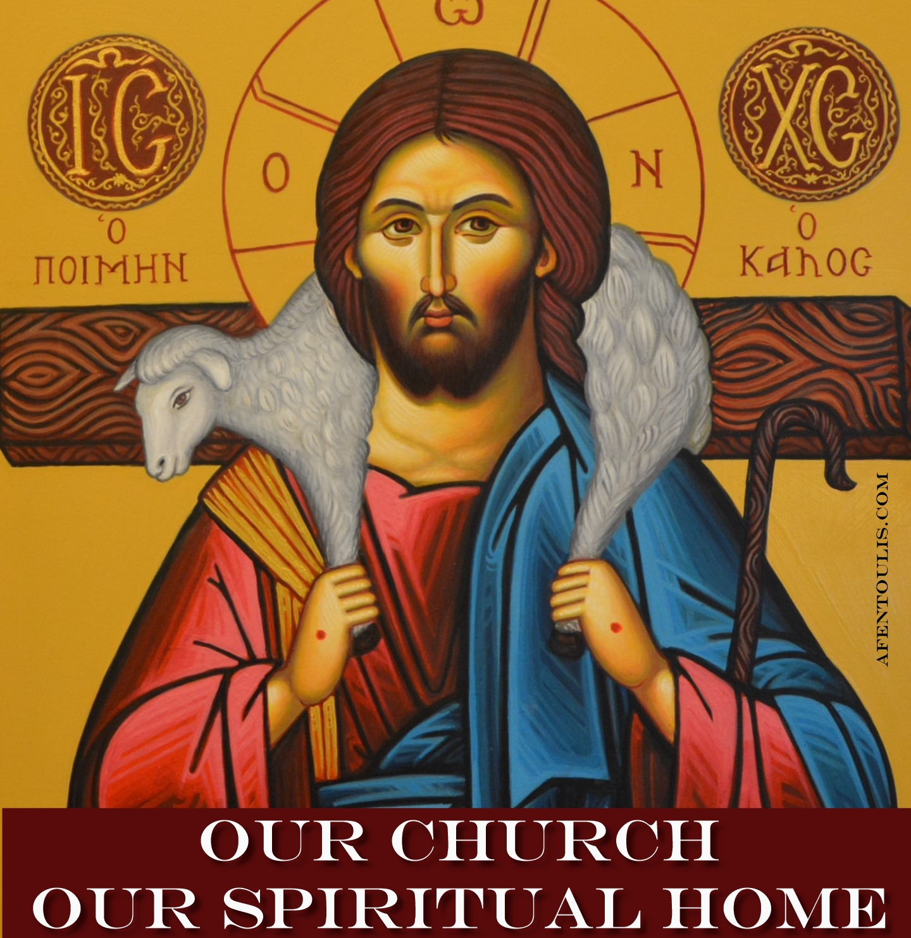
We enter our spiritual home not to be entertained, but to be a part of a community of believers. We receive Jesus Christ in Holy Communion. As we pray, worship and serve together, we become His Body. To be truly a member of the Church as Body of Christ requires our presence and our engagement with one another -- in worship, study and service to others. We grow spiritually as a family. We give sacrificially as we acknowledge that all we have comes from God.

treasure

In gratitude for God’s blessings, I/We commit to Christ and His Church the following amount:

$ each week

planned giving

 " ____I would like to speak with someone about how to remember the church in my will, trust, or estate plan."
time & talent
Individual stewards should indicate areas of interest with a check ().

Families should mark “H” for husband, “W” for wife or “C” for children.
LITURGICAL
Sanctuary & Altar Care
Altar boys / Acolytes
Baking Prosfora
Choir
Reader
Greeter/Usher

MINISTRIES & PROGRAMS
Campus Ministry
Welcome Team
New Member Events
Outreach
Stewardship
Sunday Fellowship / Coffee
Visitation – Hospital
Visitation – Shut-ins
Feed the Hungry
Prison Ministry
Grief Bereavement Group
Disaster Relief Projects
Blood Drives
Project Mexico
Int’l Orth Christian Charities
OCMC Mission Center
Seniors Ministry
Couples Ministry
Singles Ministry
Military Ministry

COMMUNICATIONS
Web site & E-mail
Bulletin & Newsletter
Public Relations

EDUCATION
Bible Study
Adult Religious Education
Intro to Orthodoxy
Publications
Speakers
Bookstore
Library

YOUTH
Church School Teacher
Church School Administration
Youth Leader
Vacation Church School
Camp Counselor

BUILDING & GROUNDS
Garden & Landscape
Plumbing
Electrical
Clean-up
Interior Repairs
Exterior Repairs
Roofing
Hall Rentals

ADMINISTRATION
Fiscal Mgt / Review
By-Laws
Development / Fundraising
Office help
Computer / Technical
Data Entry

Any other talents or information on items listed above:

Frequently Asked Questions

How do I become a member of the parish?

Membership in the Orthodox Church begins at baptism (Chrismation for some) and continues throughout our life. We are united with Christ through the sacraments, or mysteries, of the Church and through our faithful offering of our entire selves to Jesus Christ. Our Archdiocese requires each parish to distinguish between voting members and non-voting members. A voting member is over 18 years of age and turns in a signed stewardship commitment card, committing a portion of time, talent and treasure to the Church. The Archdiocese also requires the voting member to remain current through the year on their commitments. Keep in mind that true membership in the Body of Christ involves living according to His word and within His Church.

Why must I commit to give a specific amount?
Please keep in mind that your stewardship of money is kept in the strictest of confidence. However, we do compile the amounts anticipated to better plan our budget.

What if I cannot fulfill my stewardship commitment?
During the course of a year, circumstances change. Your stewardship is valued because it is made out of your love for God and His Church. Please do not be concerned if you are unable to meet your stewardship commitment – we are glad you are a part of this parish.
Eternal Life begins Now

“The Church is the unity of all worlds, earthly and heavenly, of angels and men, of the living and the dead. We obtain real communion with God and we participate in God’s uncreated energy. God does not stay in heaven, directing history from there. He directs the world with His uncreated governing energies. We do not aim at appeasing God, but to heal ourselves, so that the vision of God becomes light for us and not fire. Furthermore, in the Church we live eternal life starting from now. We do not simply await the life to come, but we experience and enjoy it from the present. The Kingdom of God, according to the Fathers, is not life beyond the grave, but communion with God, above all, the vision of the uncreated Light.”

Metropolitan Hierotheos of Nafpaktos
The Illness and Cure of the Soul in the Orthodox Tradition

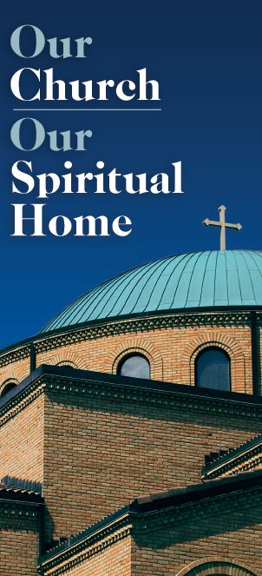

COMMITMENT CARD
2022

